Alexander Baldree, Jordan Dardar, Max Jankowski, Aftabur Rahman
Bellevue University
CSD460 Module 1 User stories

User Stories:

UST-01: Before I sign up, I want to be able to view the full site without signing up to better evaluate the marina. I want to be able to contact people if I have questions.
UST-02: As a possible new customer, I want information on the slip pricing formula, a general 10/ft + 10 Elec is great, but I want to know what my cost is before providing my info.
UST-03: As a new customer, I want an easy sign-up that includes my info with boat information. I want a single signup and reservation page.
UST-04: As a customer looking to sign up and want an easy-to-follow email verification. I want to be sure that my info is secure and have channels to inform me if something fish happened to my account.
UST-05: As a customer whose boat slip sizes are not available at the moment, I want to be informed that these slips are not available and have a clear path to sign up for the waitlist.
UST-06: As a customer who’s size slip is not available, I want to know how many people are ahead of me so I can decide whether to join the waitlist.
UST-07: As I signed up client, I want a detailed summary of my reservation. This should include my boat info, slip size, slip number, check-in date and total cost for the time reserved.
UST-08: As a returning customer, let me see my reservation ID along with all information about times I had reserved in the past. This should include checking in dates and slips I used so I can log my details.
UST-09: As a returning customer, I want to have the ability to cancel my reservation from the summery page. I then want to be returned to the reservation page where I can make a new reservation without it affecting my log information.

Users:

- Henry Morrison
  - 62-year-old fishing boat captain (retired)
  - 48 ft Trawler
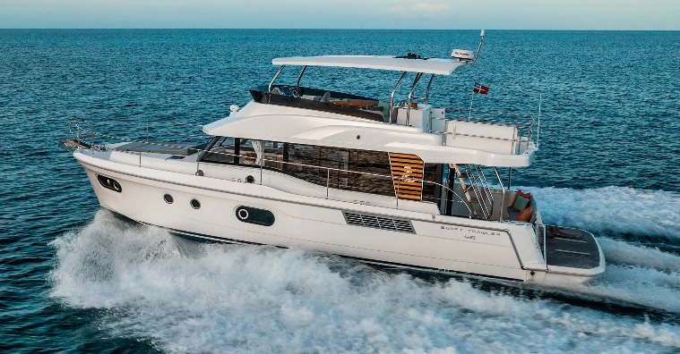

- Priya Sharma
  - 39-year-old Software project manager
  - 26 ft sailboat
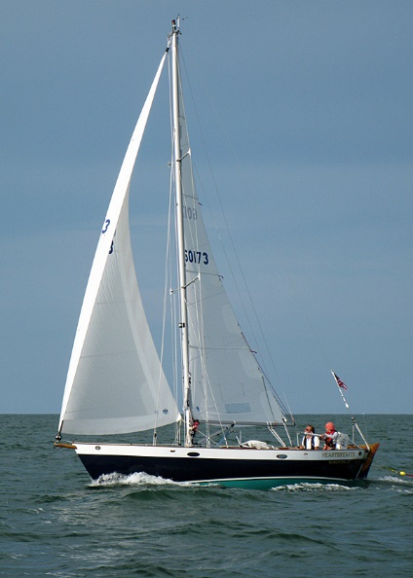

- Emily Tran
  - 37-year-old ER nurse
  - 36 ft Powerboat (She does well)
